**1.Assignment 1.**

**Configure ec2 linux machine and install apache configuration**

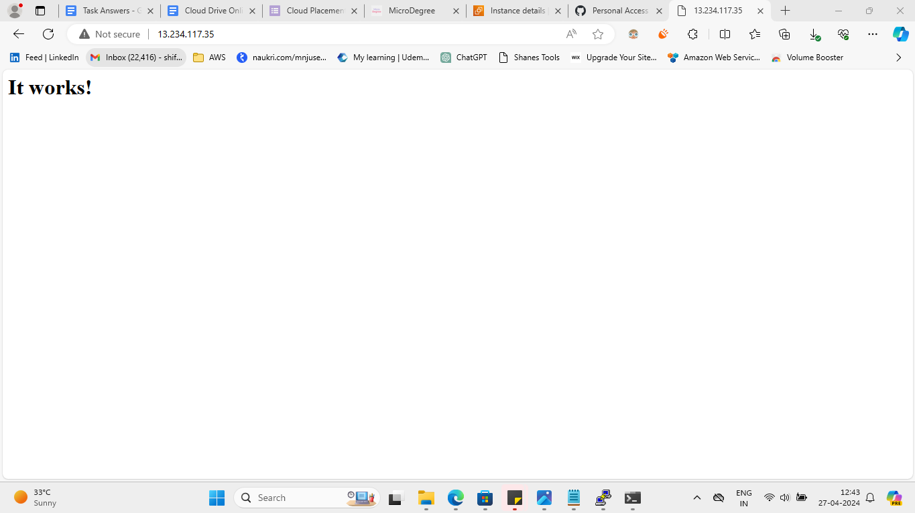

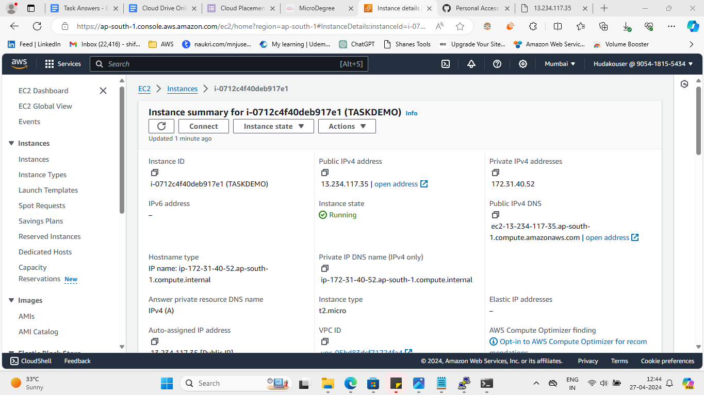

**2. Assignment 3.**

**Implement Auto Scaling: Create an Auto Scaling group that automatically launches new EC2 instances based on predefined rules. You can use the EC2 instance that you created in Task 1 as the base instance for the Auto Scaling group. Test the Auto Scaling group by simulating a surge in traffic to the web server.**

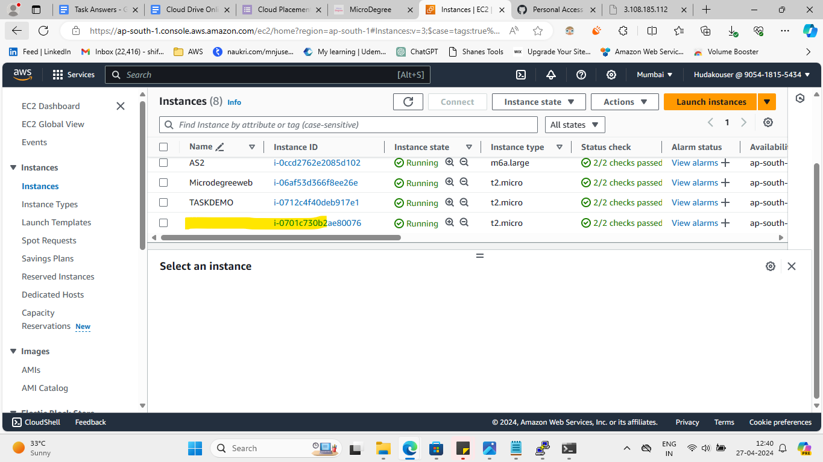

**3. Assignment 4**

**Creating a Custom Amazon Machine Image (AMI)**

**- Launch a New EC2 Instance**

**- Install http on the new instance, enable the http service to start at boot.**

**- Create a New AMI from customised instance and name the AMI MicroDegreeWeb**

**- Launch a New Instance Using the Custom AM**

**- Verify that http is running.**

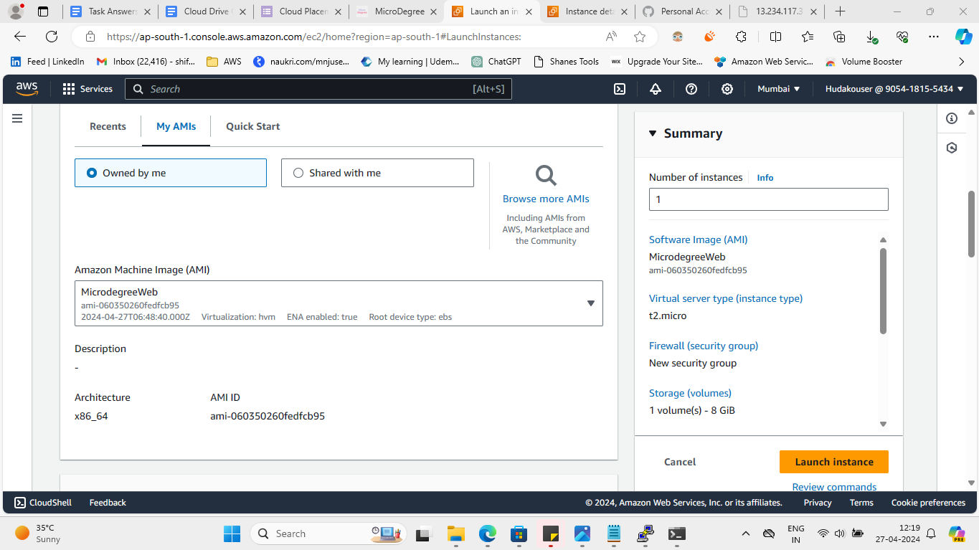

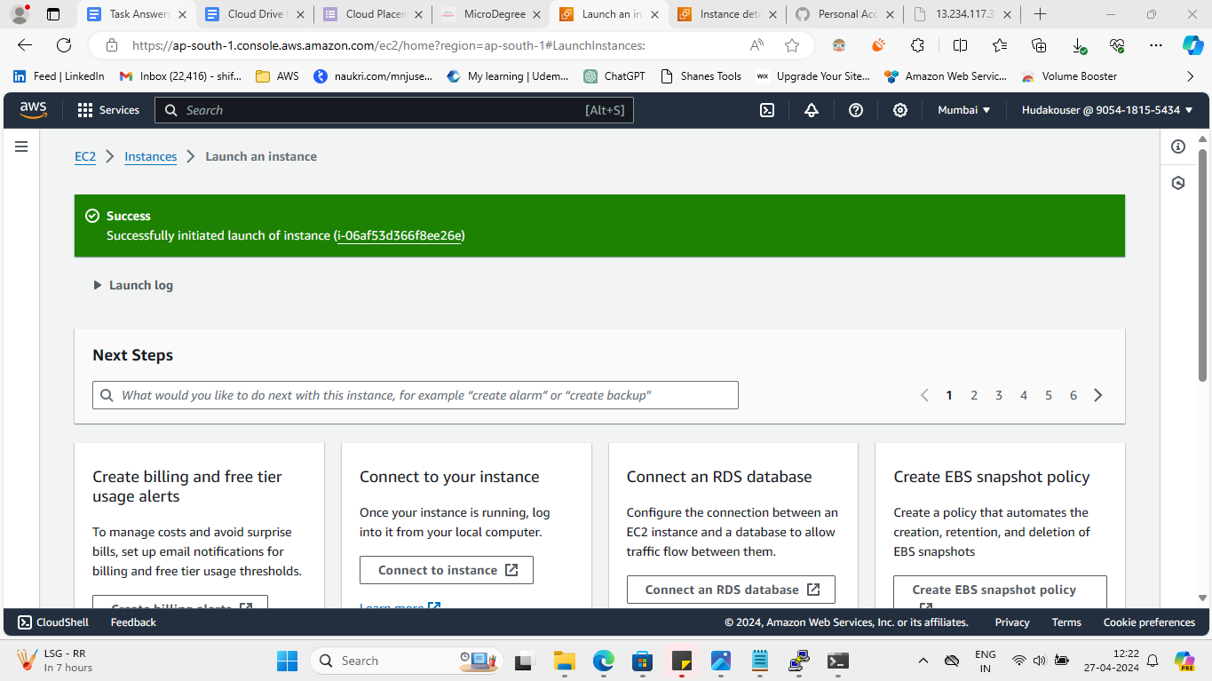

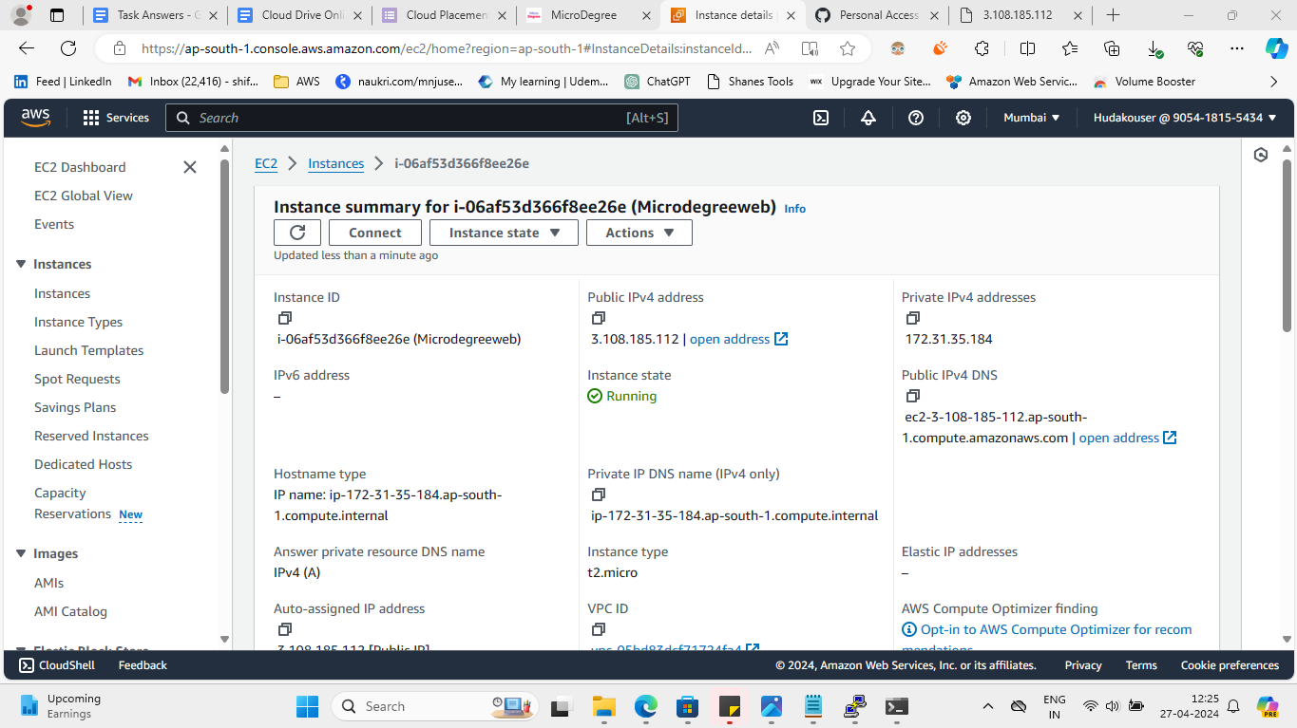

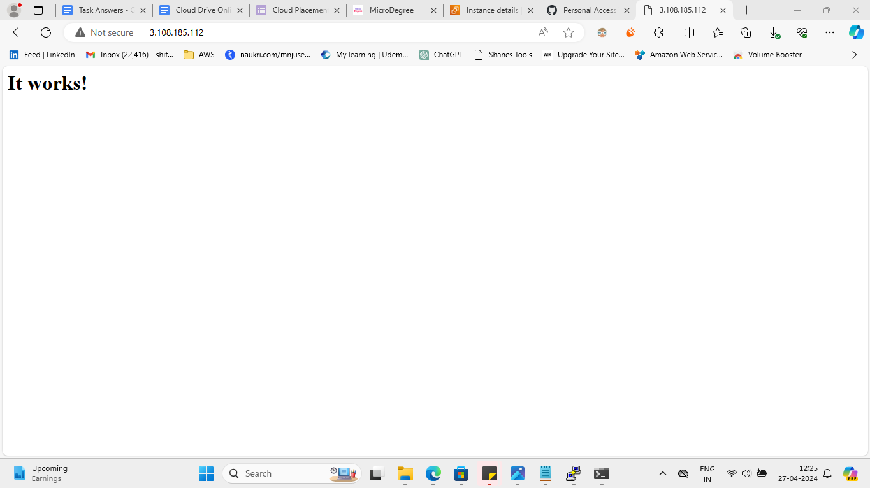

**4. Assignment 5**

Set up a basic EC2 instance: Create an Amazon Elastic Compute Cloud (EC2) instance and configure it to run a web server. You can choose any Linux-based operating system and web server software of your choice. Once the instance is up and running, access it using SSH and verify that the web server is serving web pages.

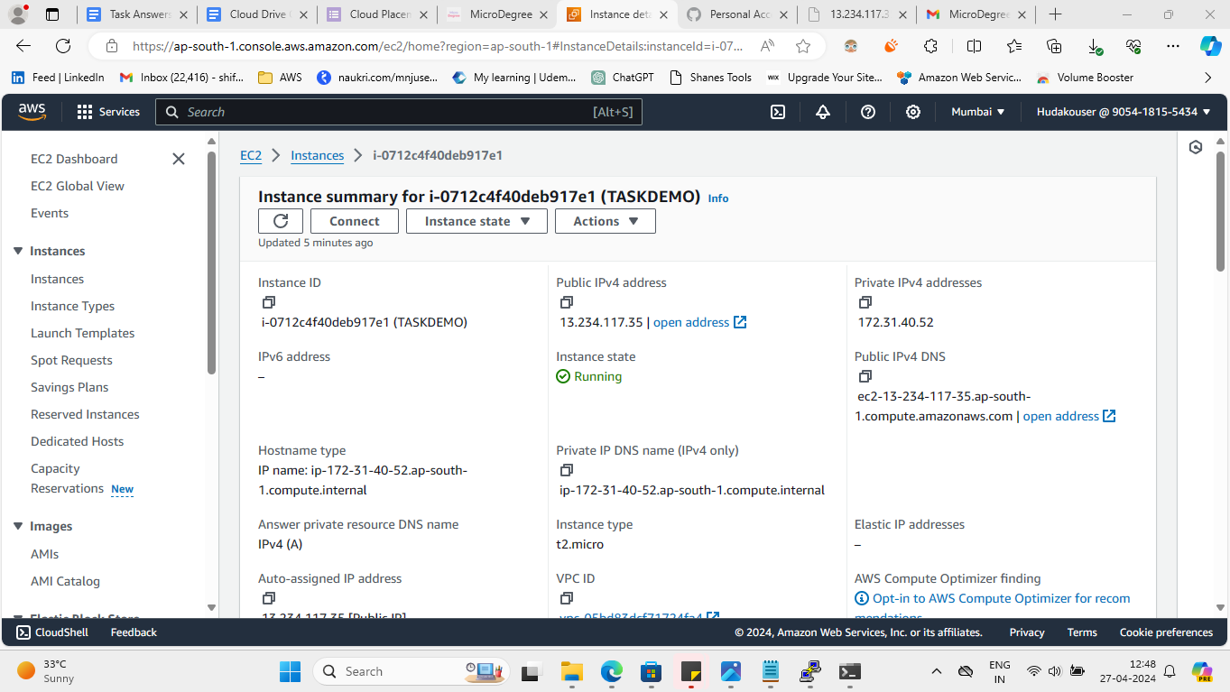  
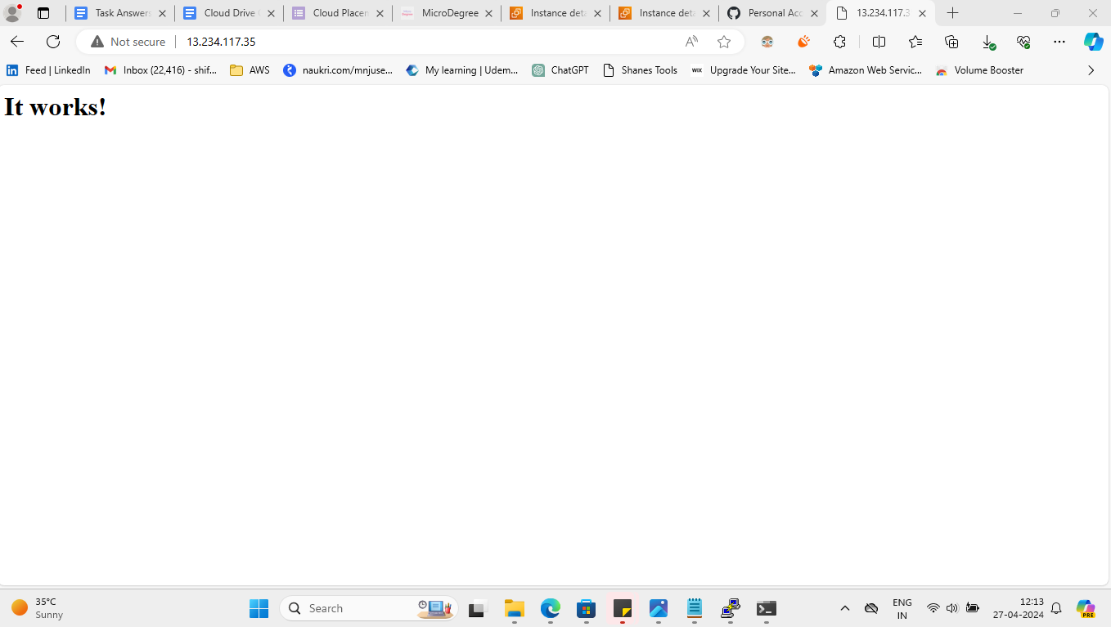

**5. Assignment 6**

Open putty, connect public IP and run some commands and show the output. Create Empty file, add some content and edit it in Vim.

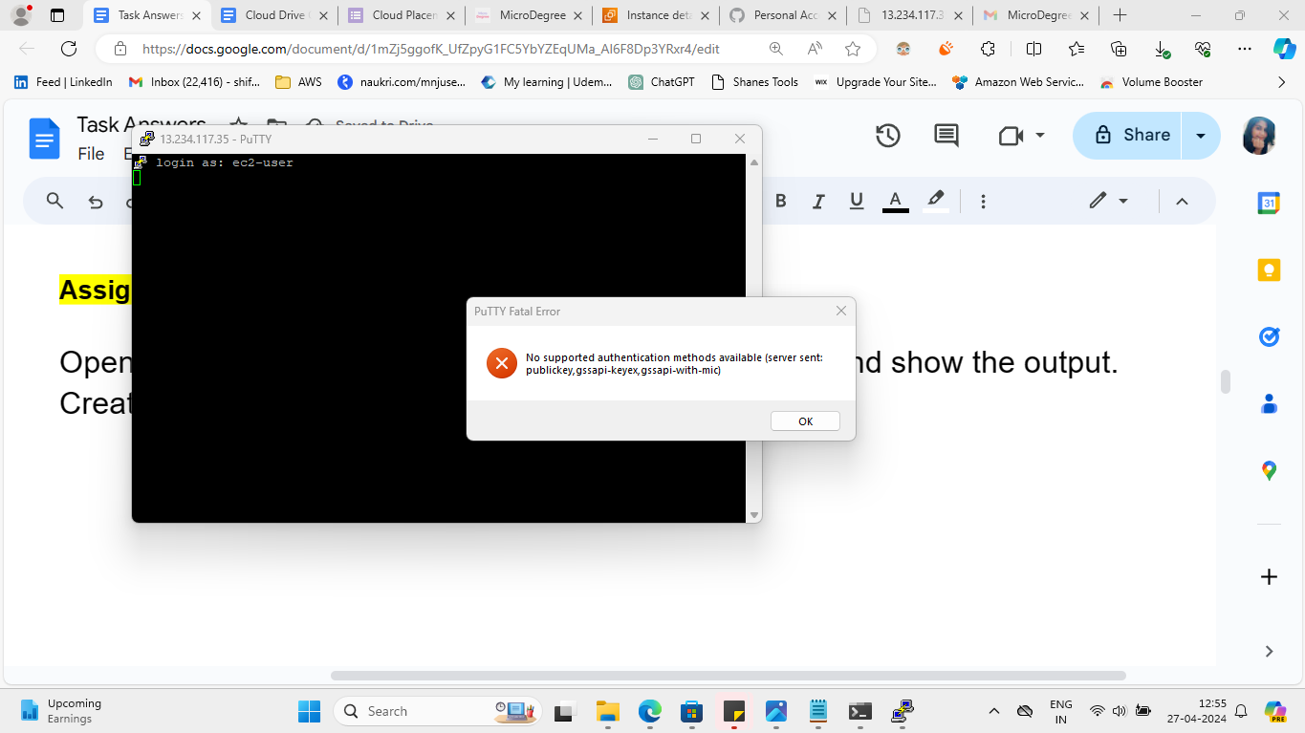

As putty is giving error, I have run commands in command prompt to show output

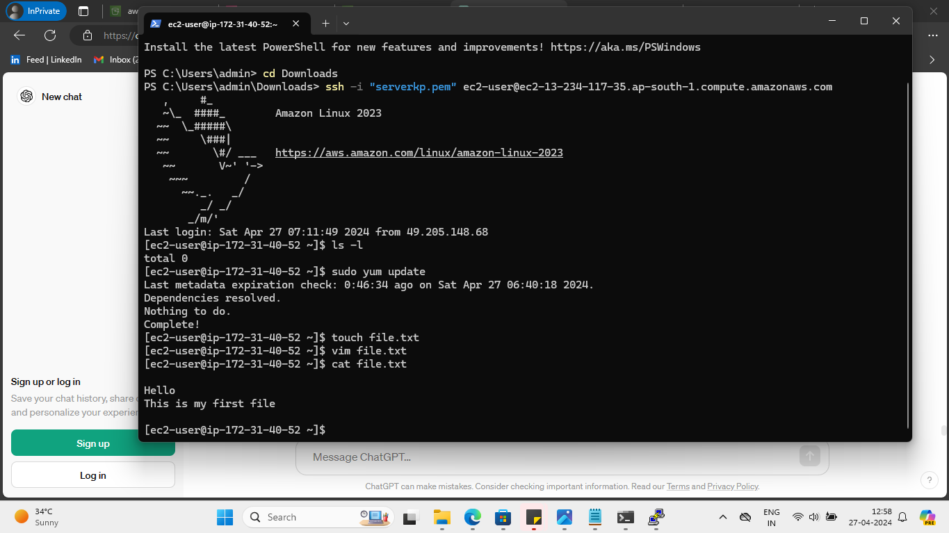

**6. Assignment 8**

Create 2 VPC's Named "Webapp-VPC" & "Db-VPC"

It should have 2 Subnets each, one with Class A IPv4 CIDR and Class B IPv4 CIDR, and 255 ports in each subnet.

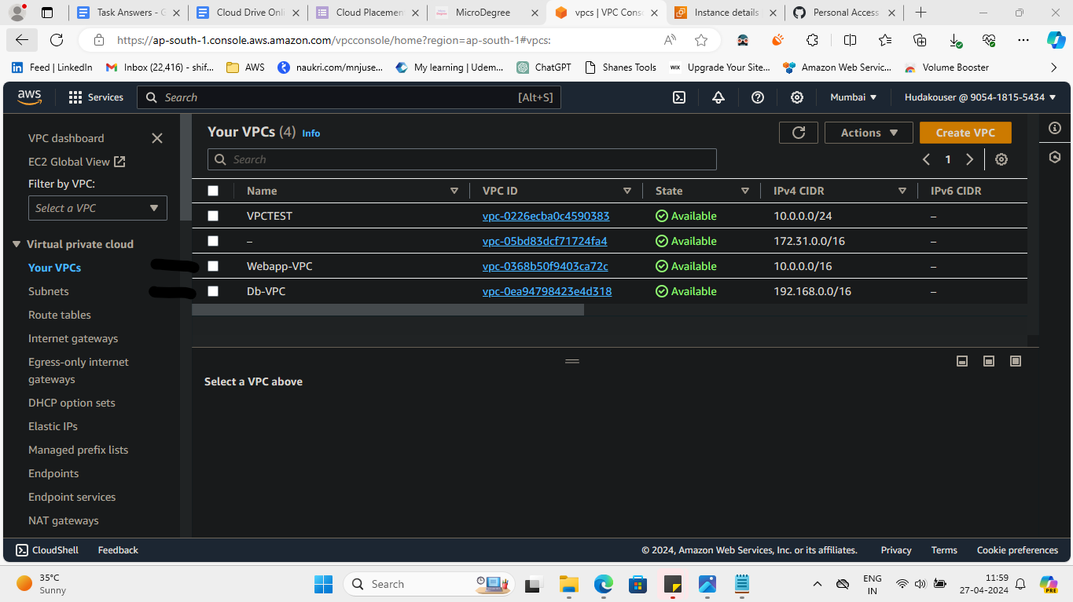

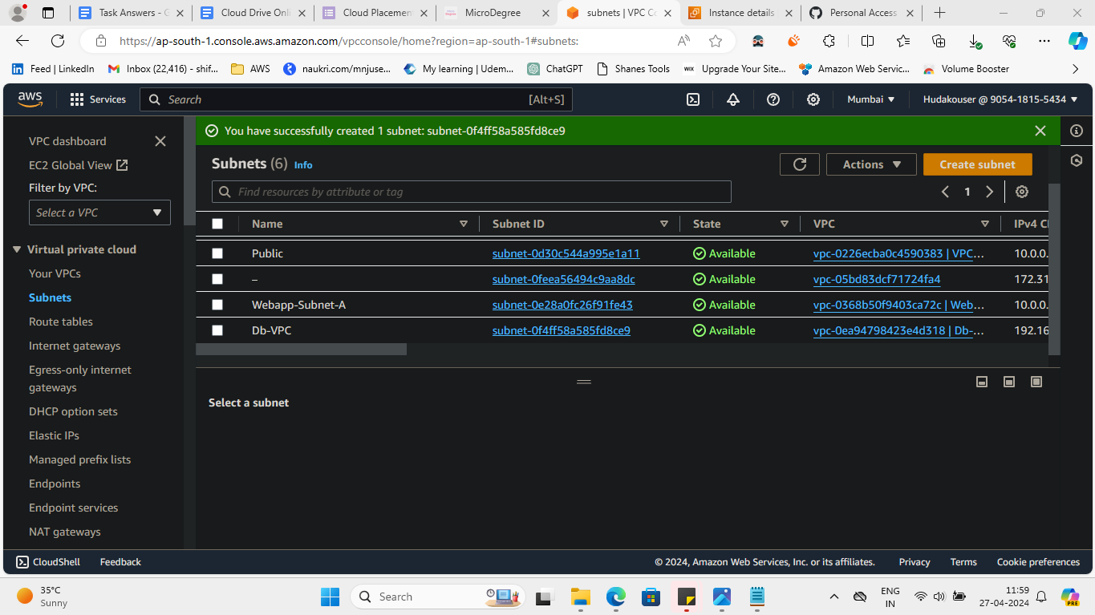

**7. Assignment 9**

Create and configure an S3 bucket: Create a new Amazon Simple Storage Service (S3) bucket and configure it for static website hosting. Then, upload a sample HTML file and ensure that it can be accessed through a web browser.

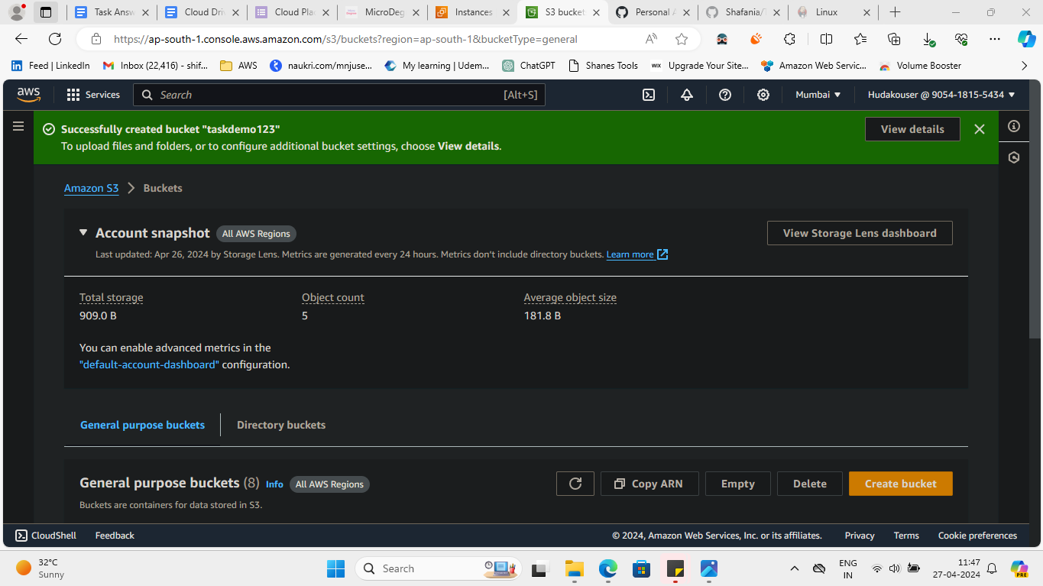

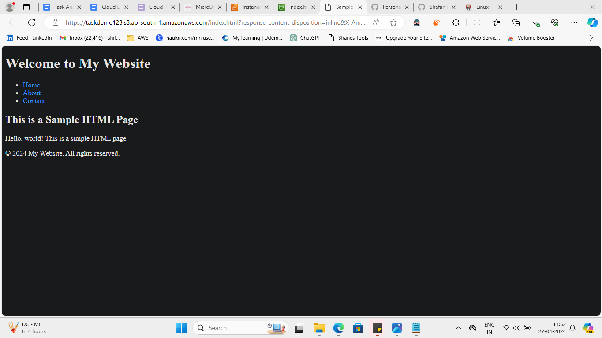

**8. Assignment 11**

**Install and configure jenkins on a server, and create a new jenkins job and configure its parameters.**

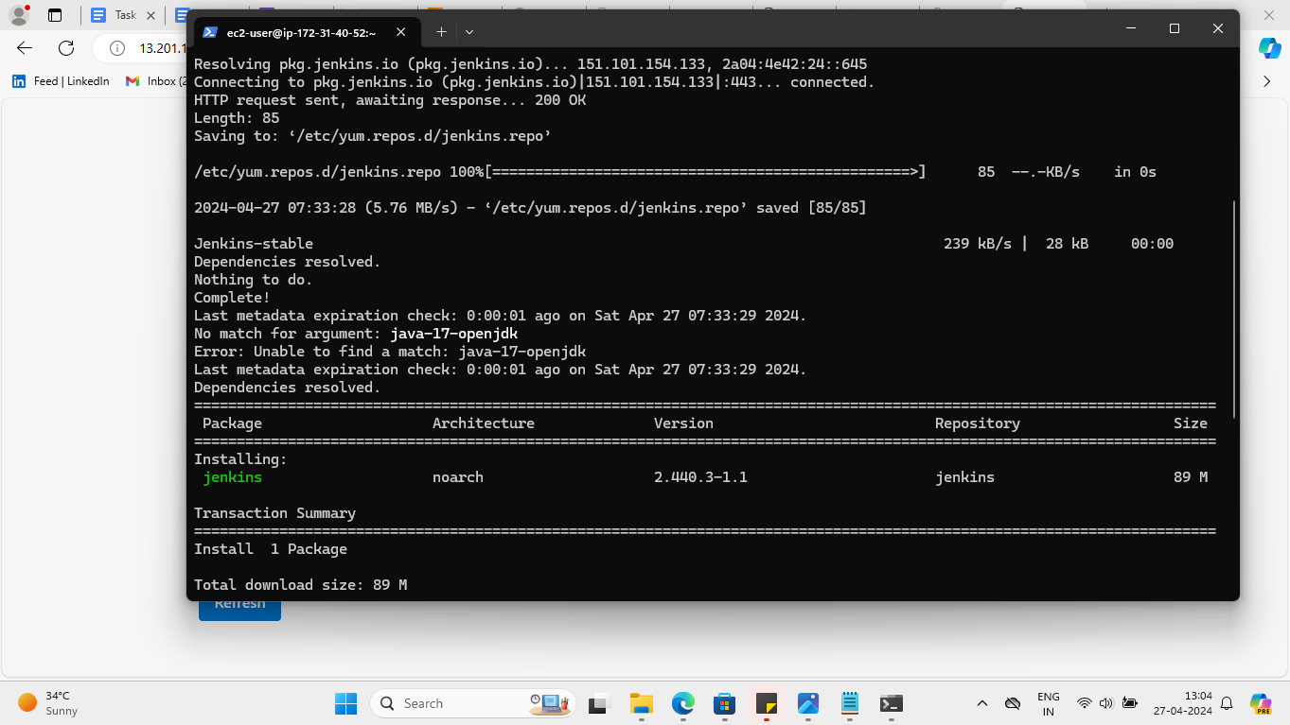

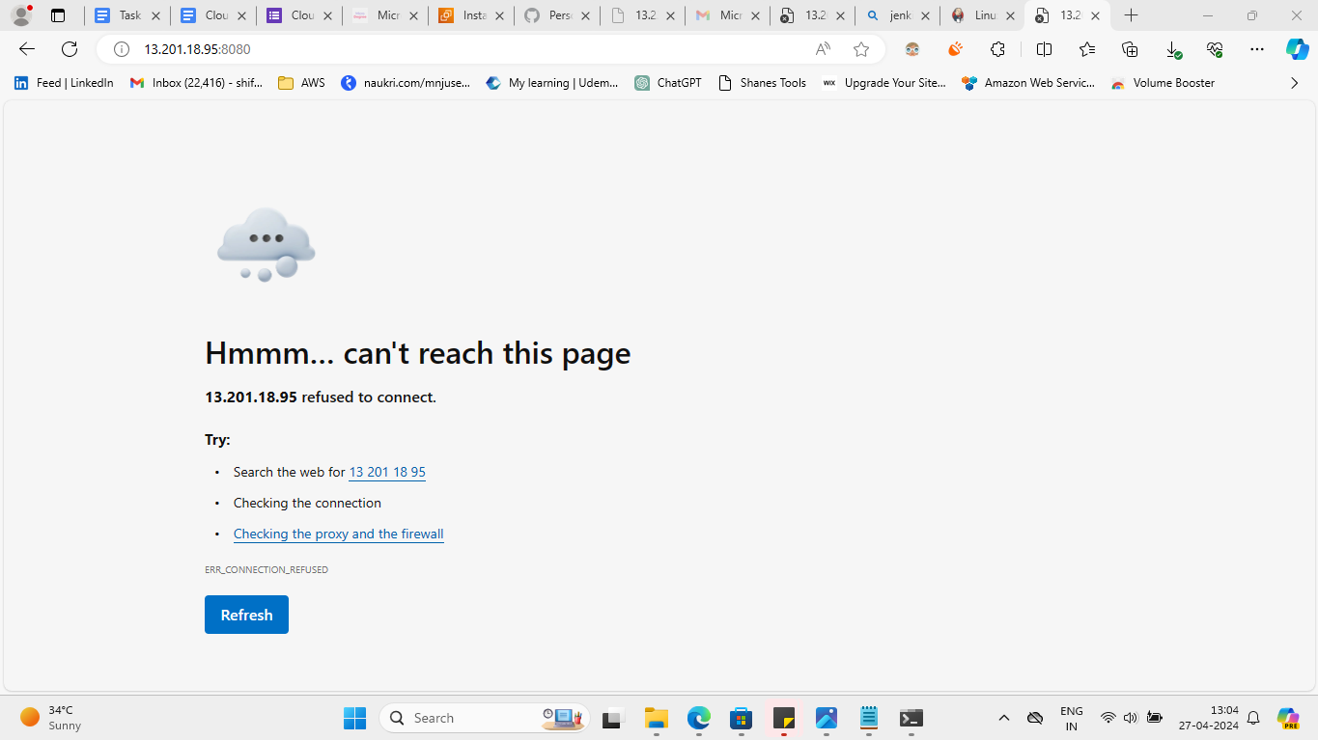

**9. Assignment 14**

Create a Staging branch in GitHub and push code from the local repository to the Remote and share the full commands screen

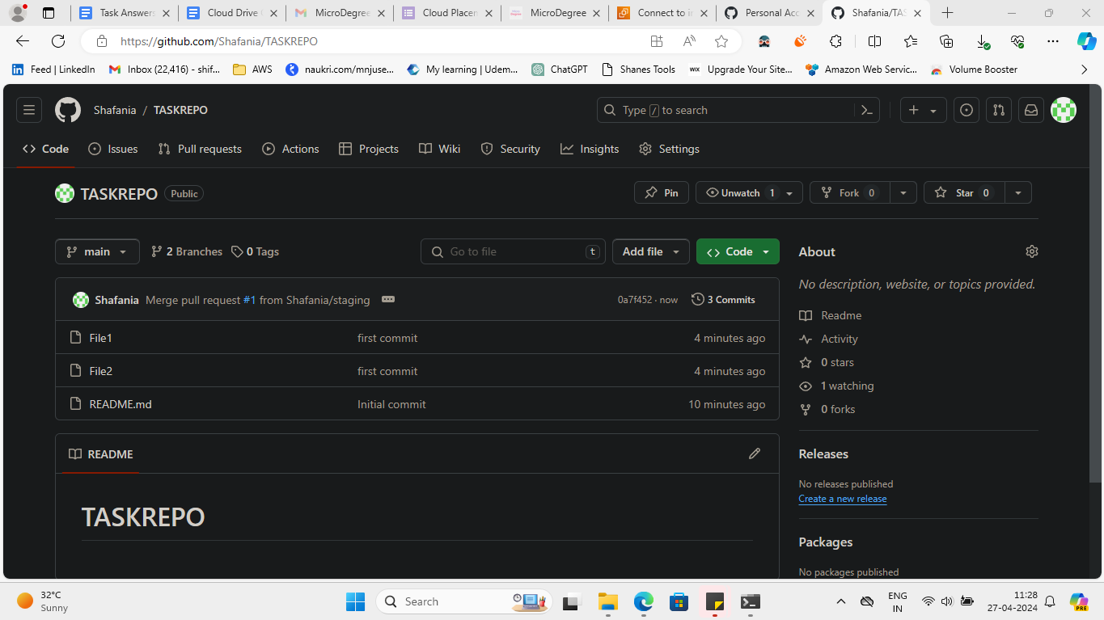

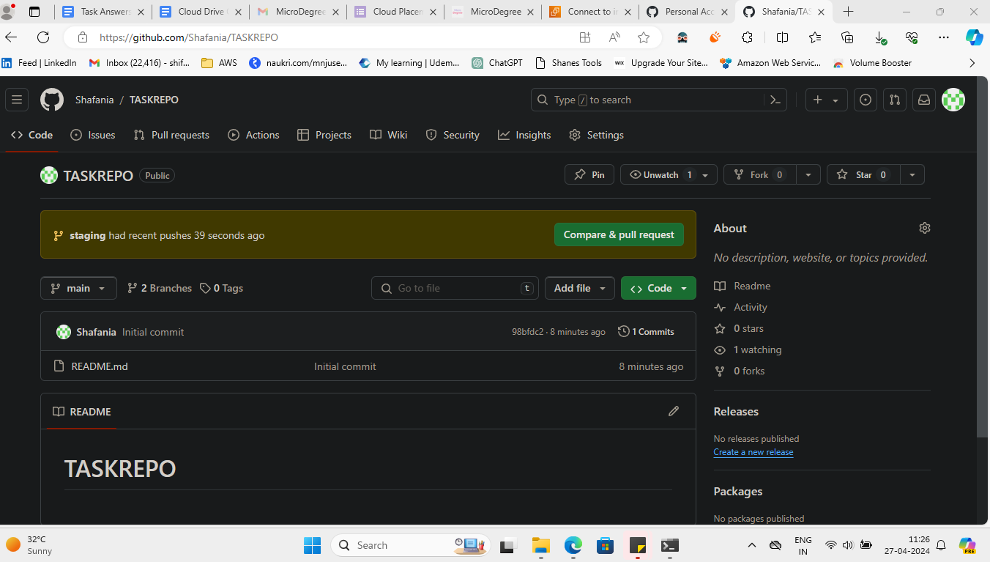

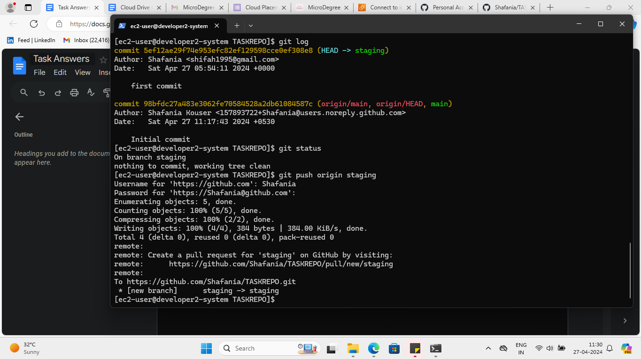

**[ec2-user@developer2-system ~]$ git clone https://github.com/Shafania/TASKREPO.git**

**Cloning into 'TASKREPO'...**

**remote: Enumerating objects: 3, done.**

**remote: Counting objects: 100% (3/3), done.**

**remote: Total 3 (delta 0), reused 0 (delta 0), pack-reused 0**

**Receiving objects: 100% (3/3), done.**

**[ec2-user@developer2-system ~]$ ls**

**Dreampro TASKREPO demo-repo hello.txt interactiveshell.sh posargu.sh sedtest.txt**

**Hello.txt case.sh firstfuntion.sh hellothere.sh lissa pro1 shelltest.sh**

**Practice csvtest.csv functionargu.sh ifelifelse.sh message.sh projects textfile.txt**

**[ec2-user@developer2-system ~]$ cd TASKREPO**

**[ec2-user@developer2-system TASKREPO]$ git checkout -b staging**

**Switched to a new branch 'staging'**

**[ec2-user@developer2-system TASKREPO]$ ls**

**README.md**

**[ec2-user@developer2-system TASKREPO]$ vim File1 File2**

**2 files to edit**

**[ec2-user@developer2-system TASKREPO]$ ls**

**File1 README.md**

**[ec2-user@developer2-system TASKREPO]$ vim File2**

**[ec2-user@developer2-system TASKREPO]$ ls**

**File1 File2 README.md**

**[ec2-user@developer2-system TASKREPO]$ git status**

**On branch staging**

**Untracked files:**

**(use "git add <file>..." to include in what will be committed)**

**File1**

**File2**

**nothing added to commit but untracked files present (use "git add" to track)**

**[ec2-user@developer2-system TASKREPO]$ git add .**

**[ec2-user@developer2-system TASKREPO]$ git commit -m"This is the first commit"**

**Author identity unknown**

**\*\*\* Please tell me who you are.**

**Run**

**git config --global user.email "you@example.com"**

**git config --global user.name "Your Name"**

**to set your account's default identity.**

**Omit --global to set the identity only in this repository.**

**fatal: unable to auto-detect email address (got 'ec2-user@developer2-system.(none)')**

**[ec2-user@developer2-system TASKREPO]$ git config --global user.email"shifah1995@gmail.com"**

**[ec2-user@developer2-system TASKREPO]$ git config --global user.name"Shafania"**

**[ec2-user@developer2-system TASKREPO]$ git status**

**On branch staging**

**Changes to be committed:**

**(use "git restore --staged <file>..." to unstage)**

**new file: File1**

**new file: File2**

**[ec2-user@developer2-system TASKREPO]$ git add .**

**[ec2-user@developer2-system TASKREPO]$ git commit -m"Message committed"**

**Author identity unknown**

**\*\*\* Please tell me who you are.**

**Run**

**git config --global user.email "you@example.com"**

**git config --global user.name "Your Name"**

**to set your account's default identity.**

**Omit --global to set the identity only in this repository.**

**fatal: unable to auto-detect email address (got 'ec2-user@developer2-system.(none)')**

**[ec2-user@developer2-system TASKREPO]$ ls**

**File1 File2 README.md**

**[ec2-user@developer2-system TASKREPO]$ git status**

**On branch staging**

**Changes to be committed:**

**(use "git restore --staged <file>..." to unstage)**

**new file: File1**

**new file: File2**

**[ec2-user@developer2-system TASKREPO]$ git config --global user.name"Shafania"**

**[ec2-user@developer2-system TASKREPO]$ git config --global user.name**

**[ec2-user@developer2-system TASKREPO]$ git config --global user.name "Shafania"**

**[ec2-user@developer2-system TASKREPO]$ git config --global user.email**

**[ec2-user@developer2-system TASKREPO]$ git config --global user.email "shifah1995@gmail.com"**

**[ec2-user@developer2-system TASKREPO]$ git config --global user.email**

**shifah1995@gmail.com**

**[ec2-user@developer2-system TASKREPO]$ git config --global user.name**

**Shafania**

**[ec2-user@developer2-system TASKREPO]$ ls**

**File1 File2 README.md**

**[ec2-user@developer2-system TASKREPO]$ git status**

**On branch staging**

**Changes to be committed:**

**(use "git restore --staged <file>..." to unstage)**

**new file: File1**

**new file: File2**

**[ec2-user@developer2-system TASKREPO]$ git add .**

**[ec2-user@developer2-system TASKREPO]$ git commit -m"first commit"**

**[staging 5ef12ae] first commit**

**2 files changed, 6 insertions(+)**

**create mode 100644 File1**

**create mode 100644 File2**

**[ec2-user@developer2-system TASKREPO]$ git log**

**commit 5ef12ae29f74e953efc82ef129598cce0ef308e8 (HEAD -> staging)**

**Author: Shafania <shifah1995@gmail.com>**

**Date: Sat Apr 27 05:54:11 2024 +0000**

**first commit**

**commit 98bfdc27a483e3062fe70584528a2db61084587c (origin/main, origin/HEAD, main)**

**Author: Shafania Kouser <157893722+Shafania@users.noreply.github.com>**

**Date: Sat Apr 27 11:17:43 2024 +0530**

**Initial commit**

**[ec2-user@developer2-system TASKREPO]$ git status**

**On branch staging**

**nothing to commit, working tree clean**

**[ec2-user@developer2-system TASKREPO]$ git push origin staging**

**Username for 'https://github.com': Shafania**

**Password for 'https://Shafania@github.com':**

**Enumerating objects: 5, done.**

**Counting objects: 100% (5/5), done.**

**Compressing objects: 100% (2/2), done.**

**Writing objects: 100% (4/4), 384 bytes | 384.00 KiB/s, done.**

**Total 4 (delta 0), reused 0 (delta 0), pack-reused 0**

**remote:**

**remote: Create a pull request for 'staging' on GitHub by visiting:**

**remote: https://github.com/Shafania/TASKREPO/pull/new/staging**

**remote:**

**To https://github.com/Shafania/TASKREPO.git**

**\* [new branch] staging -> staging**

**[ec2-user@developer2-system TASKREPO]$**

**10. Assignment 15**

Scenario:A user reports that they are unable to access a website by its domain name, but other websites are working fine. What steps would you take to troubleshoot and resolve this issue from the DNS perspective?

Perform troubleshooting DNS issues by its domain name while others function normally, few steps can be performed to diagnose and resolve the problem.

1. Checking if they're using a reliable DNS server such as their ISP's/ public DNS resolvers like Google DNS.

Incorrect DNS settings can lead to failed domain name resolution.

Google DNS (8.8.8.8)

1. Pinging the domain name can provide details into whether DNS resolution is successful. If the ping command returns an IP address, it indicates DNS resolution is functioning and directing attention elsewhere. If there's no response or an error, it shows a DNS resolution problem.

Ping Domain with command:

Command = ping domain name

1. Check DNS records through tools like nslookup to find out any missing records associated with the domain name.

A missing A (IPv4 address) or AAAA (IPv6 address) records may require updating through the domain registrar.

nslookup domainname

1. Flushing the DNS cache on the user's device helps remove cache issues that could interfere with domain resolution. This can be done through commands:

Clear cache and check, you can run command:Command: ipconfig /flushdns

1. Testing with alternative DNS servers like Google DNS can help determine if the issue is with the user's current DNS provider.
2. If the problem persists, try different devices or networks can narrow down whether the issue is device-specific or network-wide. Additionally check browser settings or firewall configurations aren't causing the problem is essential.
3. Try different browser and clear caches and cookies on browser and check if by any chance you have blocked site or made changes to website configurations.

These steps will help you find out what is the actual issue and all the steps mentioned here will help you fix the problem.